|  |  |  |
| --- | --- | --- |
| dConversing with  Urban Poor Youth on  Poverty | |  |
| Gregory Omondi Okeyo | December 2022 | Publication Name | | |
| Luke 4:18-21 (NIV) 18 “The Spirit of the Lord is on me,  because he has anointed me  to proclaim good news to the poor.  He has sent me to proclaim freedom for the prisoners  and recovery of sight for the blind,  to set the oppressed free,  19 to proclaim the year of the Lord’s favor.”  20 Then he rolled up the scroll, gave it back to the attendant and sat down. The eyes of everyone in the synagogue were fastened on him. 21 He began by saying to them, “Today this scripture is fulfilled in your hearing. |  | In this Paper  PG. 2  Introduction and Definitions  PG. 3  Poverty in the Scriptures  PG. 4  A Response to Poverty |

|  |  |  |
| --- | --- | --- |
| Introduction Many of today’s young people are afraid of poverty. Global connectivity made possible through the internet has exposed especially young people in the poor and/or developing countries to materialism, and the possibility of a quality of life far different from what they have grown up in and are used to. The effects of poverty around them are also obvious, and they are determined to escape the poverty cycles that most of them find themselves in.  In Kenya for instance, 75% of the population are under the age of 35 years, and while the 2019 census shows most of this youthful population to live in the rural areas, there is still a critical mass of youth in the urban areas, particularly the capital city of Nairobi, which is home to one of the largest informal settlements in the world.  Often, while interacting with young people in the Nairobi city metropolitan area, I have usually heard streetwise sayings such as “get rich or die trying”, or others saying the same thing. It seems like this is a shared mantra among the young people – Christian churchgoing or not. This seems to be a spinoff from the exposure to western materialistic viewpoints which allow for acquiring as much wealth as possible, by any means necessary, to ensure individual comfort. Identifying with the poor is also uncommon, as poverty (and the poor) is seen as something to run away from.  In this paper, I develop ideas for how young people can be taught to view, identify with, talk about, and tackle poverty from a biblical paradigm, and consequently ensure a transgenerational flow of material blessing that positively impacts the larger communities in which they live. |  | *What is poverty?*  One will find several definitions of poverty, depending on the context and situation it is talked about. Usually it will refer to a state in which a person or community lacks the financial resources and essentials for a certain standard of living. I once asked a group of young adults, mostly from middle class families and backgrounds, what poverty was, and the first answer that came was that poverty is *the lack of money*.  The United Nations (UN) speaks of poverty as ‘a denial of choices and opportunities and a violation of human rights’ - which expresses itself in not having enough to feed and clothe a family, or powerlessness and exclusion of individuals, households and communities, and other defined forms of lack.  The World Bank also acknowledges poverty as the pronounced deprivation in wellbeing, which comprises many dimensions.  While these definitions of poverty rightly broaden the point of view, it warrants a further look to study what the world’s best-selling book of all time (the Bible) says about poverty.  “…poverty (and the poor) are seen as something to run away from.” |
| Poverty in The Scriptures The Christian scriptures are replete with references to ‘the poor’, ‘poverty’, and ‘lack’. The Bible, both in the Old Testament (OT) and in the New Testament (NT), uses different words that clarify the different aspects and causes of poverty.  There are five main root words that are used in the Old Testament to talk about poverty (Grigg, 2004). Firstly, *Chaser* (used 36 times in the OT) and which defines poverty from the point of view of ‘to suffer lack of bread and water, or to hunger.’ This is poverty that will afflict one due to personal sin.  The book of Proverbs highlights these sins, for example, wickedness (Proverbs 13:25), too much sleep (Proverbs 6:10-11), hasty planning (Proverbs 21:5), loving pleasure (Proverbs 21:17), miserliness and gambling (Proverbs 28:22) – all of which are the average present-day young person’s daily struggle.  The Bible is clear, that sin causes poverty, and it is also clear from the Bible and from our observations that poverty also causes sin. Grigg suggests that the solution to this kind of poverty is a preaching of the gospel that frees the people from their bondages onto the grace of their Lord and establish a deep level of discipleship.  Then there is poverty that is caused by a natural calamity or other unfortunate happening such as death of a breadwinner, etc. This kind of poverty is described by the biblical words *Ebyon* (used61 times in the OT), which speaks of poverty as the state of being needy and dependent, and *Dal* (used57 times in the OT), which speaks of poverty as frailty and weakness. Job 29:11-16 speaks to this kind of poverty. Much of the poverty experienced today by widows and children would be described in this way.  “There are five main root words that are used in the Old Testament to talk about poverty”  He highlights Job – the rich man who became poor. In Job, we see faith and behavior being tested – initiated by Satan but allowed by God. We see that lack and destitution is not always a bad thing, especially when one considers God’s purposes in it all.  Bellingham then highlights David – the poor man who became rich, again in fulfilment of God’s plans and purposes. Other perspectives are given of Solomon – the rich man who became richer, and from the wisdom of Asia’s Mahatma Gandhi.  All these historical figures cement the fact that material things are not everything in life. Material lack is temporary and does not necessarily equate to the ultimate poverty. The scriptures do ask the rhetorical question: *“And what do you benefit if you gain the whole world but lose your own soul? Is anything worth more than your soul?”* (Matthew 16:26, NLT).  The roots of poverty are deeper and should not be underestimated (or overestimated), but should be examined and addressed accordingly, as we co-work with God in His redemption plan. Poverty too, serves the eternal purposes of God, who is at work restoring man and creation.    Figure : Rooftops in the outskirts of Lashio, Northern Shan State, Myanmar  Referring to Isaiah 61:1-3, Snyder (1985) suggests that prophet Isaiah uses the theme of Jubilee as a picture of the goal of God’s Kingdom – which then provides the background for Jesus’ own proclamation of the kingdom when he clearly identified with the Jubilee theme as recorded in Luke 4:18-24.    Grigg, in the online article *Proclaiming The Good News of a Kingdom Jubilee* (2006) asks the question: “When people heard him (Jesus), what did they understand?”  Jesus proclaimed a jubilee gospel. A gospel in which spiritual, social, economic, liturgical, historical dimensions were/are interwoven. When the people listened to Jesus, they heard the Jubilee call that had already been ringing from the OT – Liberty, Debt Cancellation, Celebration, and Redistribution of the means of production (land). Grigg asserts that these four are timelessly inherent in the gospel to the present.  We see the equalizing effect of the gospel within the church in the book of Acts. The apostles seem to have imparted this culture of communal living within the early church, as we read testimonies like: *“All the believers were united in heart and mind. And they felt that what they owned was not their own, so they shared everything they had. The apostles testified powerfully to the resurrection of the Lord Jesus, and God’s great blessing was upon them all. There were no needy people among them, because those who owned land or houses would sell them and bring the money to the apostles to give to those in need. For instance, there was Joseph, the one the apostles nicknamed Barnabas (which means “Son of Encouragement”). He was from the tribe of Levi and came from the island of Cyprus. He sold a field he owned and brought the money to the apostles.”* (Acts 4:32-37, NLT).  Grigg comments that the ‘no needy people among them’ has to do with the meeting of all basic needs, not excess wants and pleasures.  Our heavenly Father has a bias in favor of the poor, and Christ the son demonstrated this, discipling his followers in the same mind, who then in turn entrusted to many other reliable men.  *Conclusion*  For many young people, acquiring as much wealth as possible, by any means necessary is the way to disassociate from poverty. Ironically, this pursuit for greater levels of wealth does not seem to have the communal good in mind. Targeting the younger generations, the complete gospel of the Kingdom needs to be preached. The gospel has, unfortunately been associated with material poverty, and the perpetuating of it. Yet it is the very engagement with the gospel that would bring a liberation from the injustices of oppression and dispossession and from conflict, and unto the reality of the kingdom of God.  In this paper, I have shown that the biblical theme of Jubilee if well proclaimed will enable a much-needed paradigm shift especially among young urban poor in the present day, from a more individualistic and materialistic approach of addressing poverty, to a more biblical and sustainable and transgenerational approach. |  | Grigg further notes that those experiencing this kind of poverty can easily be crushed and abandoned without means to recover from their losses or from the calamity (see Job 20:19). Grigg further suggests that the solution to this kind of poverty is walking alongside the dependent poor and endeavoring to meet their present apparent needs.  1 John 3:17 (NLT) says *“If anyone has the world’s goods, and sees his brother in need, yet closes his heart against him, how does God’s love abide in Him?”*  In a culture that idolizes and promotes the acquisition of the most amount of wealth for personal/individual gratification, teaching young people to see the world with the lenses of the scriptures, and to develop God’s heart for the poor is a necessary.  The fourth and fifth words used in the OT are *Ani* (used 80 times) and *Rush* (used 31 times in the OT). These two words represent the kind of poverty that is caused by oppression. ‘Rush’ sees poverty as dispossession. Ani, on the other hand sees poverty as being the result of affliction and oppression – the state of humiliation that comes from being bowed down under (external) pressure. This is the category of poverty that is caused by the sins of the rich, or of leavers, or of conquering nations.  Bellingham (1987) also draws from the Bible’s wisdom literature (Job, Psalms, Proverbs, Ecclesiastes, Song of Solomon) in giving some perspectives on poverty.  *A Response to Poverty*  Does the Bible give a response to poverty? I believe so. In this section I will endeavor to show how the biblical theme of the Jubilee opens doors for insights into an appropriate response to poverty.  Of its many implications, the more relevant for our discussion is the fact that the concept of the jubilee especially focusses on the interests of the poor.  We see the theme of Jubilee first appearing in the OT book of Leviticus, then being further developed by the prophets. God gives the instructions saying:  *“In addition, you must count off seven Sabbath years, seven sets of seven years, adding up to forty-nine years in all. Then on the Day of Atonement in the fiftieth year, blow the ram’s horn loud and long throughout the land. Set this year apart as holy, a time to proclaim freedom throughout the land for all who live there. It will be a jubilee year for you, when each of you may return to the land that belonged to your ancestors and return to your own clan.”* (Leviticus 25:8-10, NLT)  Extrapolating the effect of this equalizing gospel, the result should be that the destitute poor of the society are moved upwards to a level where they can work for their basic needs (laboring poor), and so move out of their destitution, while the laboring poor can also move towards the middle class. The very rich of society contribute to this reorganization of the economic systems in which they live and benefit from. The diagram below further illustrates the same.    Figure : Adapted from Prof. Viv Grigg, 2004  This obviously does not come naturally to fallen man and has to take the hand of God by the preaching of the full gospel, to allow for the upper percentiles of the society (the rich and the middle class) to forfeit some of what they are accustomed to, in order that the rest of society who are the majority are uplifted.  Starting from choosing a simple sacrificial lifestyle motivated by the love of God to supporting institutionalized mechanisms and structures that promote justice, we can all find a way to proclaim the gospel of the Kingdom.  Indeed, the epistles also exhort the same. One of the epistles says *“And God will generously provide all you need. Then you will always have everything you need and plenty left over to share with others.”*  (2 Corinthians 9:8)  *Works Cited*  Bellingham, G. R. (1987). The Equality Model: Helping the Poor Participate. *A Biblical Approach to Social Transformation*. PhD Thesis. Philadelphia, Eastern Baptist Seminary.  Bellingham, G. R. (1987). The Wisdom Literature: Perspectives on Poverty. *A Biblical Approach to Social Transformation*. Philadelphia, Eastern Baptist Seminary. Ch. 7.  Grigg, V. (2004). *God’s Happy Poor*. In *Companion to the poor*. Monrovia, CA, Authentic Media. Chap 3.  Grigg. V. (2002. rev 2006). *Proclaiming the Good News of a Kingdom Jubilee.* Accessed December 22, 2022  Grigg, V. (2004). *Biblical reflections on land and land rights.* Urban Leadership Foundation. Accessed Dec 29, 2022  Kenya National Bureau of Statistics (2020). *2019 Kenya Population and Housing Census*  Snyder, H. (1985). The Age of Jubilee. *A Kingdom Manifesto*. pp. 67-76 |

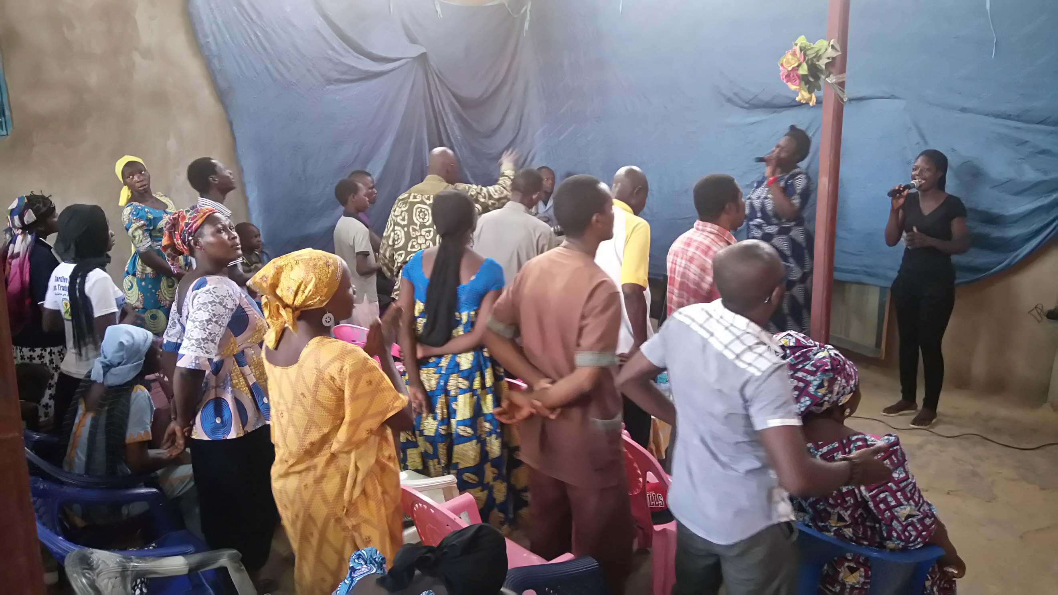

Figure : A local church service at the outskirts of N'Djamena, Chad

Extrapolating the effect of this equalizing gospel, the result should be that the destitute poor of the society are moved upwards to a level where they can work for their basic needs (labor poor), and so move out of their destitution, while the labor poor can also move towards the middle class very rich of society contribute to this reorganization of the economic systems in which they live and benefit from. The diagram below further illustrates the same.